**Project Design Phase-I Solution Architecture**

|  |  |
| --- | --- |
| Date | 12 OCTOBER 2022 |
| Team ID | PNT2022TMID31875 |
| Project Name | IoT based safety gadget for child safety and  notification system |
| Maximum Marks | 4 Marks |

# Solution Architecture:

Solution architecture is a complex process – with many sub-processes – that bridges the gap between business problems and technology solutions. Its goals are to:

* Find the best tech solution to solve existing business problems.
* Describe the structure, characteristics, behavior, and other aspects of the software to project stakeholders.
* Define features, development phases, and solution requirements.
* Provide specifications according to which the solution is defined, managed, and delivered.

# FEATURES:

Development of a safety gadget for children to ensure their protection without direct monitoring of their parents. The various features involve:

* + GPS
  + Geo fence
  + Notify alert signal

# SOLUTION:

Track current location of the child using GPS and continuous monitoring of the same is done. When the gadget detects the activity to be outside the given geo fence (as mentioned by the parent or guardian), alert messages or notifications are sent to the registered device, appropriately. Additional features such as recording of messages could be done if any kind of danger is sensed.

# SOLUTION ARCHITECTURE DIAGRAM:

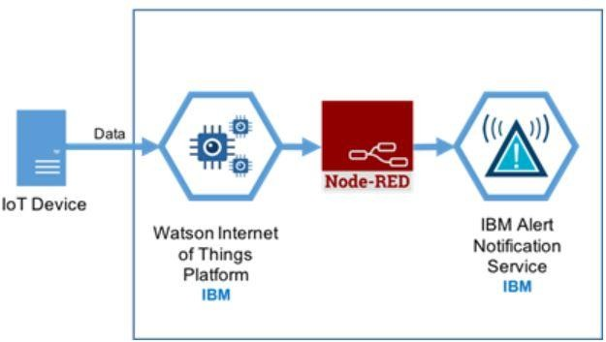

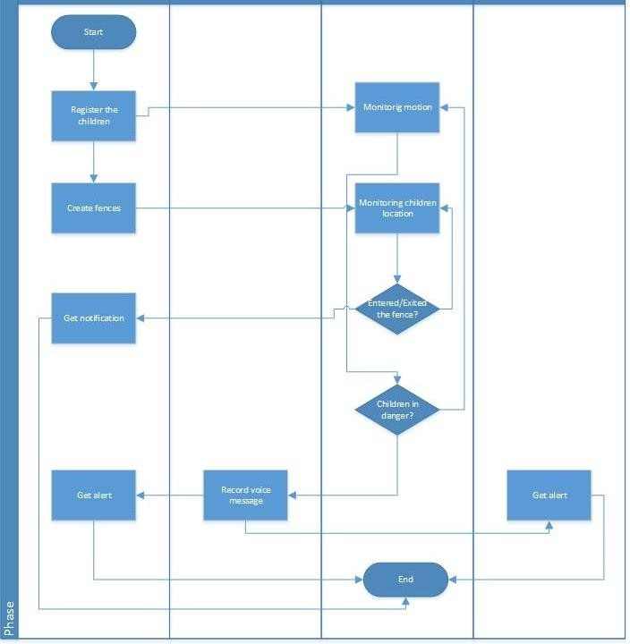

*Figure 1: Architecture and data flow of the child safety gadget system*